Shareholder Annual Meeting
Saturday – June 24, 2023
10:00 a.m.

Dockton Water Association Community Hall
9710 SW Windmill Street

Ballot Measures
The agenda will include voting results by the Association’s membership (*) on the following measures:

- Board of Directors Election
- Proposed Budget for 2023-2024
- Amendment to the Bylaws

Voting Ballot

Your ballot must be received no later than 10:00 a.m. on Saturday, June 24 to be counted. Ballots may be mailed or dropped off at the DWA office.

Please provide your account #(s):

1. Board of Directors Election (vote for three (3) candidates; statements enclosed as a separate document)
□ Darton Riely-Gibbons (2-year term)
□ Todd Currie (2-year term)
□ Paul Witherspoon (2-year term)
□ Write-in candidate (print name):_______________________________________________

2. Budget for 2023-2024 (on the back of this page)
□ Approve □ Do not approve

3. Modification to Association Bylaw 1.7 (on the back of this page)
□ Approve □ Do not approve

Budget Summary

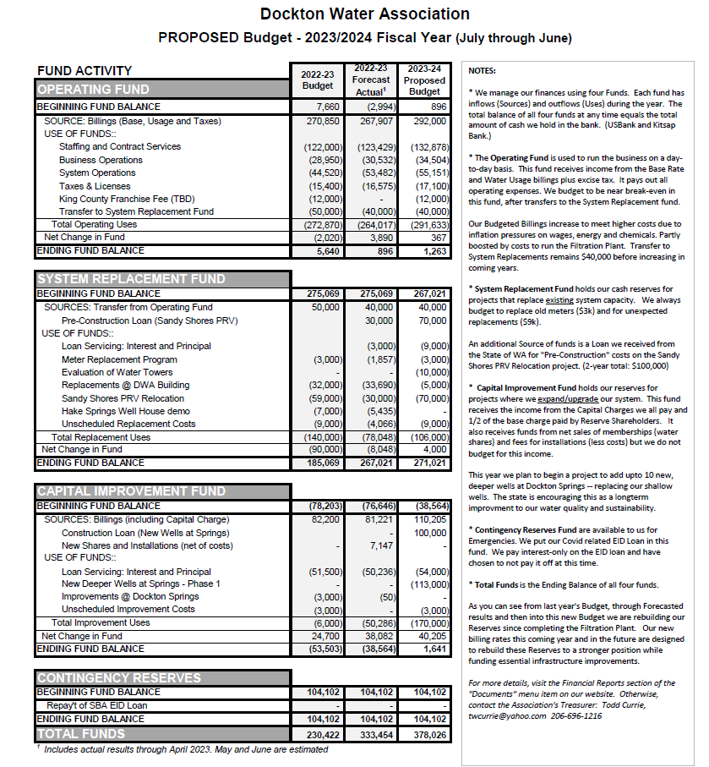

Explanation of Ballot Questions

Ballot Question 1: Who should be elected to the three open board positions?

Three Board positions expire on June 24, 2023. Candidate statements are printed on the back of this page. You can also write in a candidate. Please vote for 3.

Ballot Question 2: Should the Board adopt the proposed budget for 2023-2024?

The proposed budget is printed on the ballot, enclosed as a separate document. Notes in the right column give a general explanation of the format and contents. For more details, please visit docktonwater.org. For specific questions, contact Todd Currie at twcurrie@yahoo.com.

Ballot Question 3: Should Dockton Water association amend bylaw 1.7 as outlined below? The change is shown in bold.

1.7. MEMBERSHIP OWNERSHIP.
A membership is assigned to a specific property and transfers with that property upon change of property ownership only when all outstanding water bills charged to that property have been paid. Transfer to another property is not allowed, regardless of ownership, except when approved by the Board of Directors. When a member wishes to relinquish their membership, the member will be reimbursed by the Association at the then current Membership Reimbursement Fee less any amounts owing the Association (or as otherwise defined in any purchase agreement) and subject to the Board’s then current Waiting List Policy.

Old text: When a member wishes to withdraw, the membership may be sold only to the Association at the current membership fee paid (or as otherwise defined in any purchase agreement) provided that a waiting list exists for the purchase of the share. The membership will then be offered to the next property on the shares waiting list.

More information is available here on our website at https://www.docktonwater.org/membership-fee/.

Candidate Statements
Board of Directors Election
Term begins July 2023 and runs through June 2025 (2-year)

Darton Reilly-Gibbons (2-year term)
Darton Riely-Gibbons is a professionally licensed civil engineer in the state of Washington that specializes in land development and stormwater management. For the past ten years, he's worked as a civil engineer consultant. He currently works at CPH Consultants in Kirkland as a project manager. Prior to that, he worked as a project manager for four years with Huitt-Zollars, Inc. in Tacoma and four years with MacKay Sposito, Inc. in Federal Way. Darton received his Bachelor of Science in Civil Engineering from Seattle University and has lived in the Puget Sound region his entire life, growing up on Bainbridge Island, and now living on Vashon with his wife, Kim, and two daughters; Hadley (6) and Poppy (3). Darton has served on the Dockton Water Association Board since 2017 and as President since 2020 and head of the Capital Improvements Committee since 2018. Darton is excited to continue to serve on the Dockton Water Association Board and utilize his skill set and engineering experience to play a more active role in his community.

Todd Currie (2-year term)
I've enjoyed serving on the board since the Fall of 2015 and will be glad to continue serving the association if re-elected. I am retired from a career in the software industry, most recently at Tableau Software. Much of my career has involved financial reporting and data analytics systems. I have an undergraduate degree in Accounting (Penn State) and an MBA (University of Chicago) -- so I really enjoy working with the numbers! My wife, Sylvie, and I split our time between Dockton and Fremont. I'm currently doing quite a bit of work with Dave and Angie to continue improving how QuickBooks can support our "Fund Accounting" system and with Dave and the Board to extend the horizon of our financial planning further into the future.

Paul Witherspoon (1-year term)
I have been serving on the board since 2013. During this time I have been part of, and witnessed great changes and improvements in how DWA serves this community. With my background/profession in Construction Management and Facility Management, I look forward to providing my knowledge and skill set in making continuing improvements in sustainability, production, storage, and distribution of our most precious community resource- our good tasting, clean water. I am asking for your vote so I may continue to serve my community.

